**ASSIGNMENT 3 –**

**DIVIJA L**

**PES1UG20CS134**

**SEN 5 - SEC C**

1. Find the solution to 9X9 sudoku problem(with/without initial hints)

**Backtracking**

**Backtracking is a kind of brute-force approach which comes into picture when solving a problem requires considering multiple choices as we don't know which choice is correct and we try to solve the problem using trail and error method considering one choice at a time until required answer is obtained.**

_

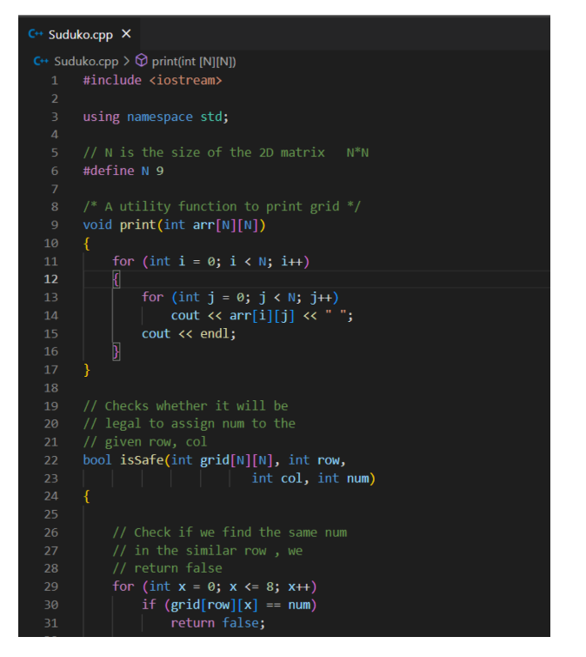

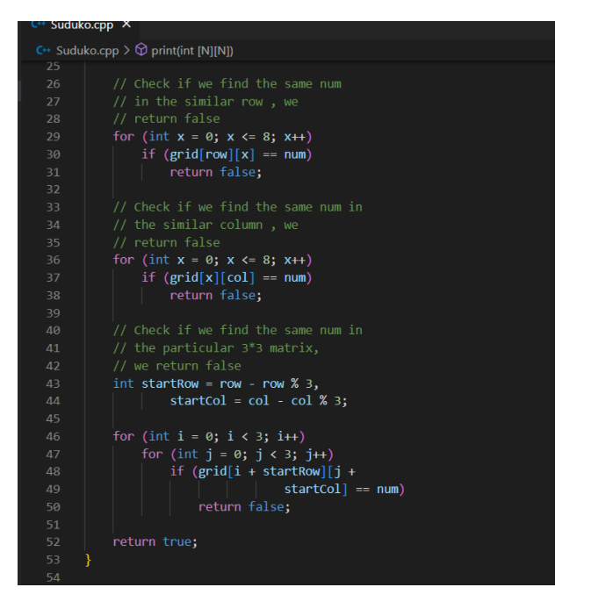

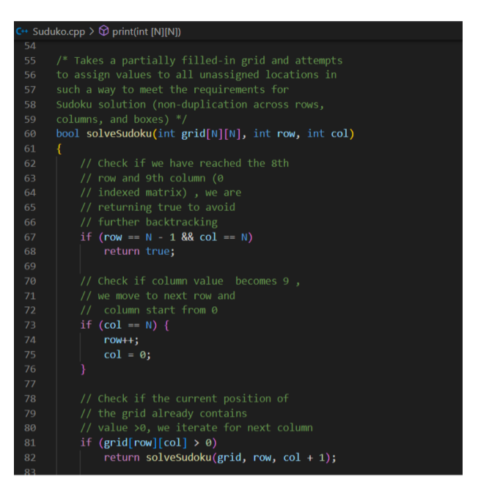

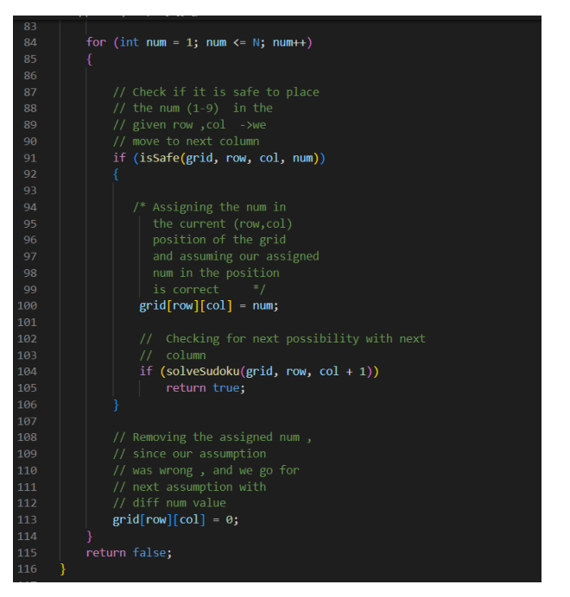

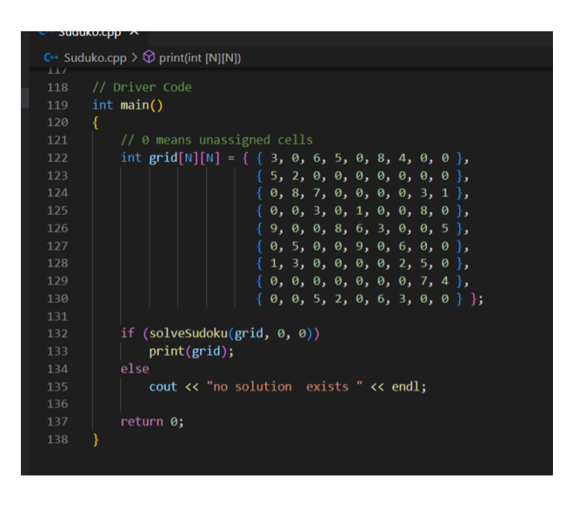

Output:

